**Lesson 09 Demo 02**

**Next-js-routing-app**

**Objective:** To demonstrate the next js server side routing application base upon the path provide by browser.

**Tools required:** Node JS and React JS

**Prerequisites:** HTML, CSS, JavaScript ES5/ES6, Basic React Concept

**Note** : All react js project already created with version 18.x with Sample App.js file

**Steps to be followed:**

1. Set up for next js project
2. Create more than one component
3. Now we run the application.

**Step 1: Set up for next js project**

1. Open the terminal window **inside the next-js-routing-app** folder

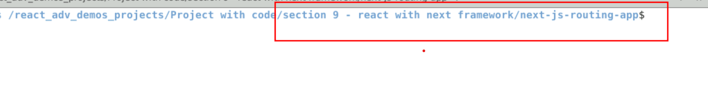

1.2 run npm install to download the dependencies.

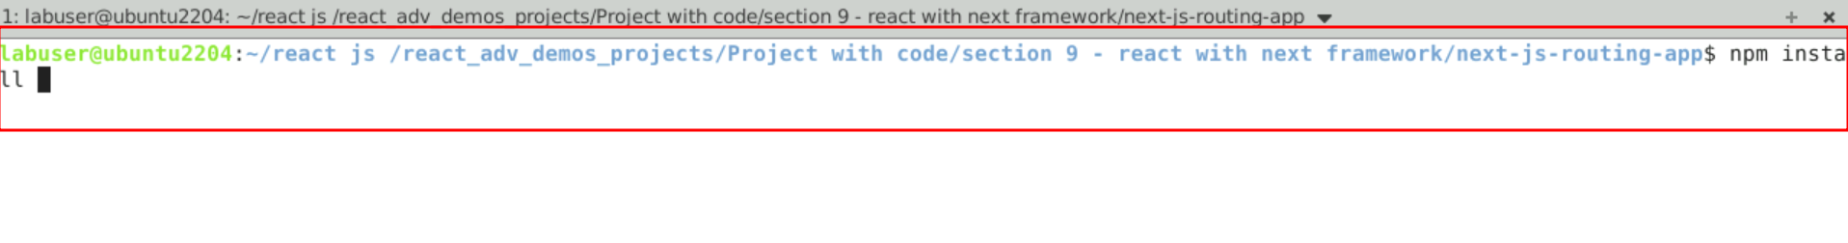

* 1. Open the project in VS code

Note: short cut to open write **code .**

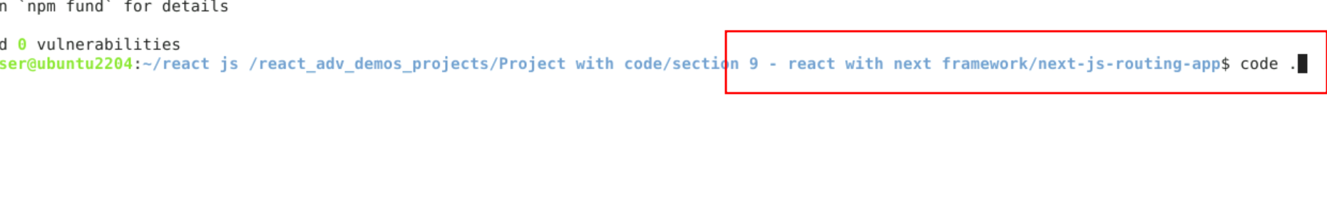

* 1. view the project structure

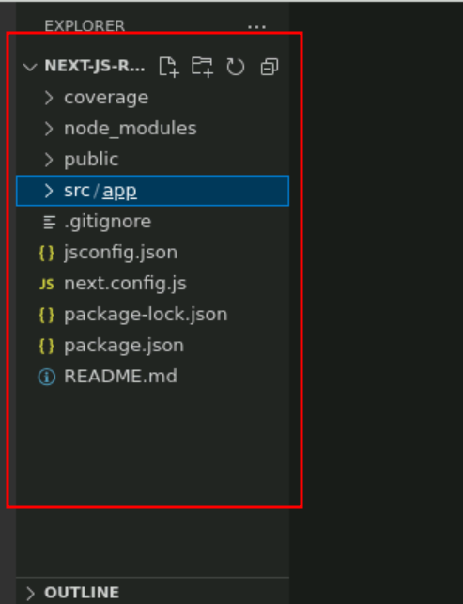

**Step 2: create more than one component**

To create the component in next we need to create the folder. The folder name itself is consider as path. Inside that folder we need create the page.js file which contains next js component help to render base upon the path provided through browser.

2.1 create about folder and inside folder create page.js file

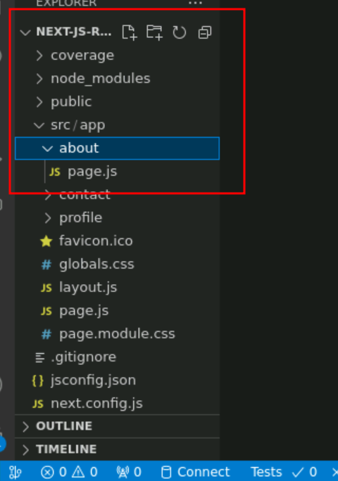

**page.js file**

export default function AboutUs() {

return(

<div>

<h3>About Us Page</h3>

<p>About Us page Description</p>

</div>

)

}

2.2 create contact folder and inside folder create page.js file

page.js file

export default function ContactUs() {

return(

<div>

<h3>Contact Us Page</h3>

<p>Contact Us page Description</p>

</div>

)

}

2.3 create profile folder which contains sub folder as adminprofile as well as userprofile sub folder which contains page.js file (which is consider as nested routing).

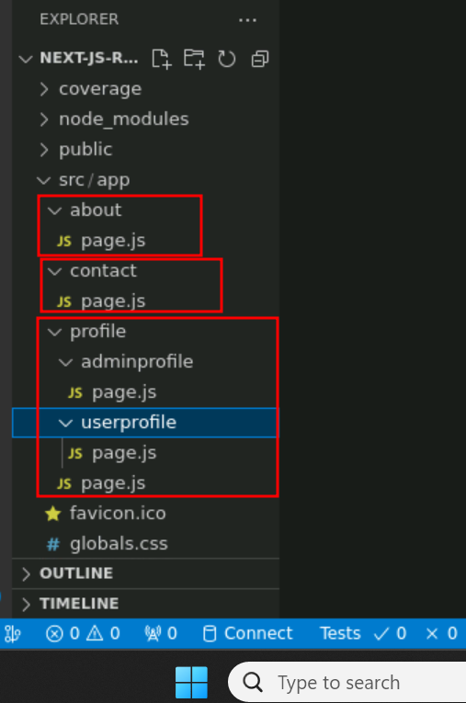

2.4 in page.js file part of app folder edit with below code

**page.js**

import Image from 'next/image'

import styles from './page.module.css'

export default function Home() {

return (

<main className={styles.main}>

<div>This is next routing example</div>

</main>

)

}

**Step 3 :Now we run the application.**

3.1 open the terminal inside the project and run the application we need to use the command as

**npm run dev**

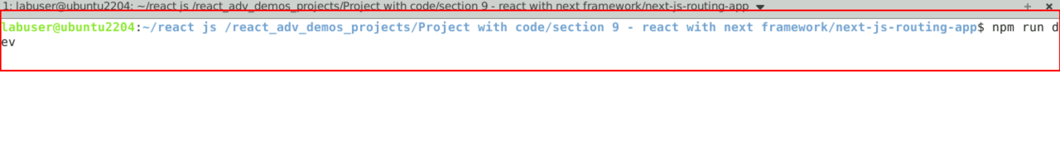

3.2 Now open the browser and write the URL as

<http://localhost:3000>

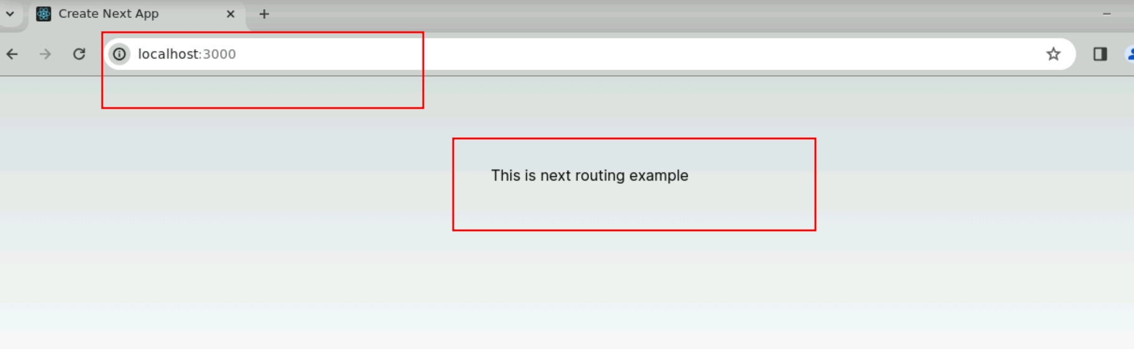

3.3 about us page route

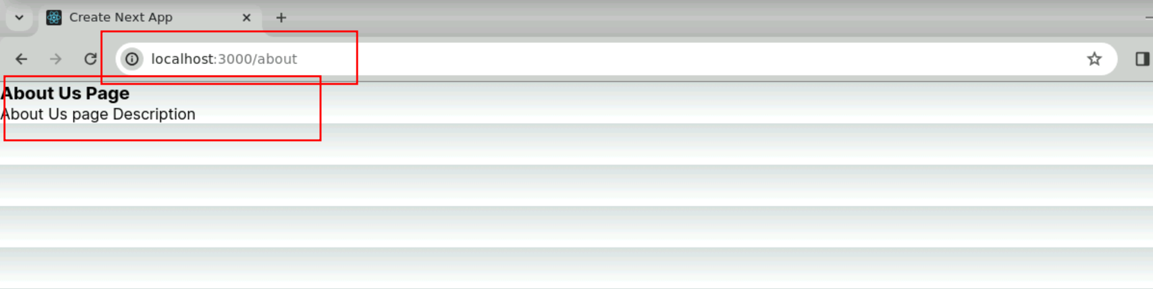

3.4 contact us page route

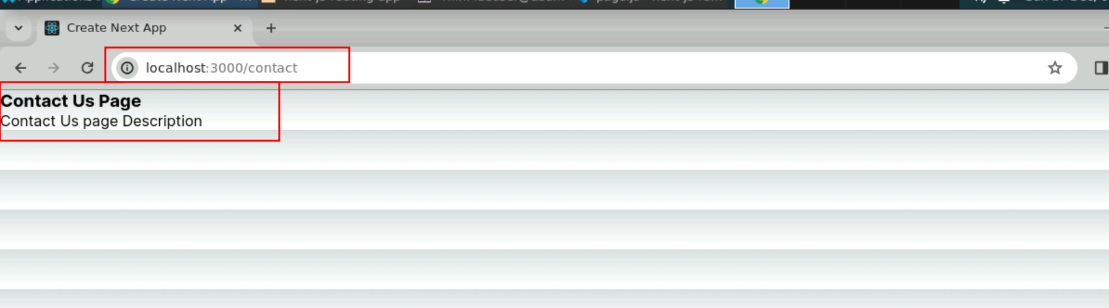

3.5 profile with adminprofile nested route

